COMPUTER SYSTEMS
CFGS DAW



UNIT 7. Windows Administration -Part 2-

Alfredo Oltra / Sergi García
alfredo.oltra@ceedcv.es
sergio.garcia@ceedcv.es

2019/2020
Versión:190926.1236

Licencia


Reconocimiento – NoComercial – CompartirIgual (by-nc-sa): No se permite un uso comercial de la obra original ni de las posibles obras derivadas, la distribución de las cuales se debe hacer con una licencia igual a la que regula la obra original.

Nomenclatura
A lo largo de este tema se utilizarán distintos símbolos para distinguir elementos importantes dentro del contenido. Estos símbolos son:

◻ Importante

 Atención

 Interesante

INDEX
1. Introduction 3
2. System properties 3
2.1 Advanced system settings 4
2.2 Device manager 7
3. Security management 8
4. Disk Management 9
5. Msconfig 10
6. Additional material 12
7. Bibliography 12

Introduction
In this part we continue studying Windows operating system. It’s mandatory to read and understand previous class notes to continue with part 2.

System properties
In this video you can watch several ways to go to “System properties” in Windows 10
http://www.isunshare.com/windows-10/6-ways-to-open-computer-or-system-properties-in-windows-10.html
The most common way to arrive is right click on “This PC” and then in properties.
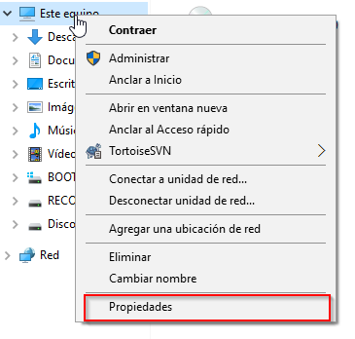
System properties is a menu where we can check our system specs like CPU, RAM, Windows version….
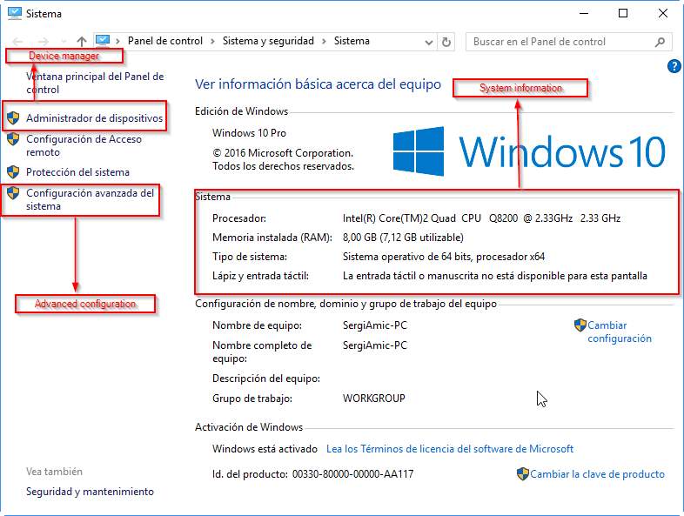
We are going to study two sections of System properties: “Advanced system settings” and “Device manager”

Advanced system settings
In “Advanced system settings” we have several tabs, each one with a lot of options to modify.
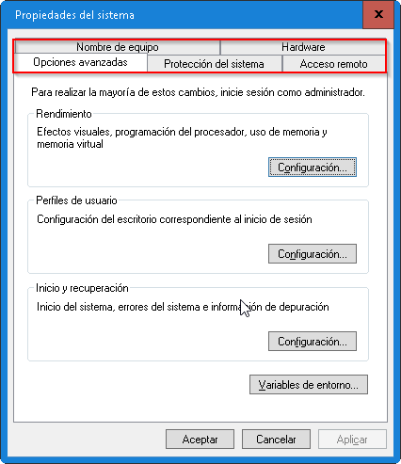
The most important functions are:
Tab “Advanced options”: you can configure several things, like user profiles, start and recovery, performance and environment variables.
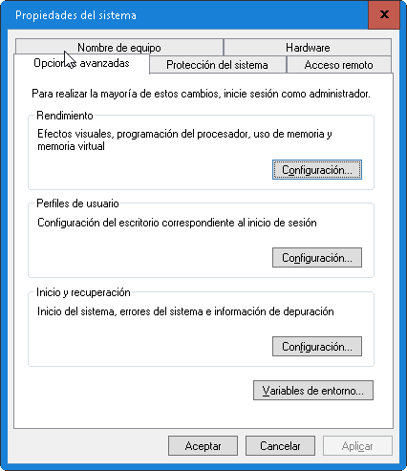
Most important features are:
  - Performance: you can configure how many resources uses your desktop (for example, deactivating effects for low computers) and configure how your system uses virtual memory.
  - Environment variables: there you can define environment variables. It is useful to configure a lot of applications, like development environments.

Tab “System protection”: you can configure things like “System restoration”. We recommend do not use system restoration (Disable it) and use other programs to make backups of your system, like “Clonezilla” http://clonezilla.org/ .

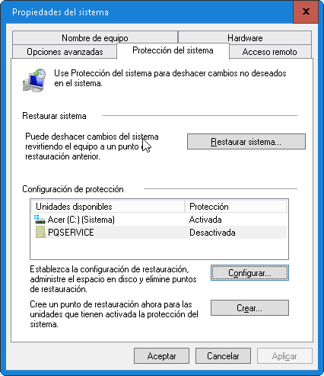
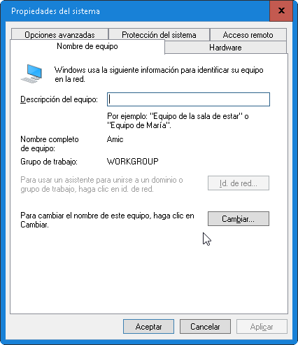
Tab “Computer name”: you can change computer name and also you can configure your Windows to be in a workgroup or to join a domain.

Tab “Remote access”: there you can configure if you can recive remote access (for example, for receive support through Internet).
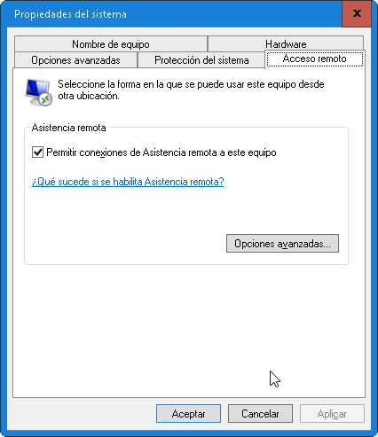
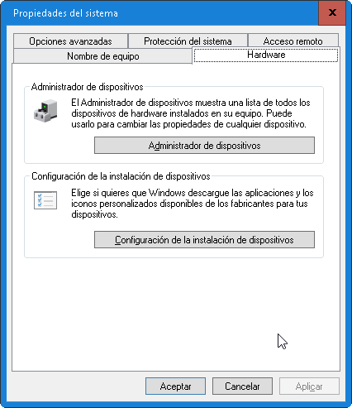
Tab “Hardware”: you can access to device manager and run a manager to add new devices.

Device manager
Device manager is menu to manage devices of our computer.
In this Video you can watch several ways to go to “Device Manager” in Windows 10 https://www.youtube.com/watch?v=nEyQMq7bwlY
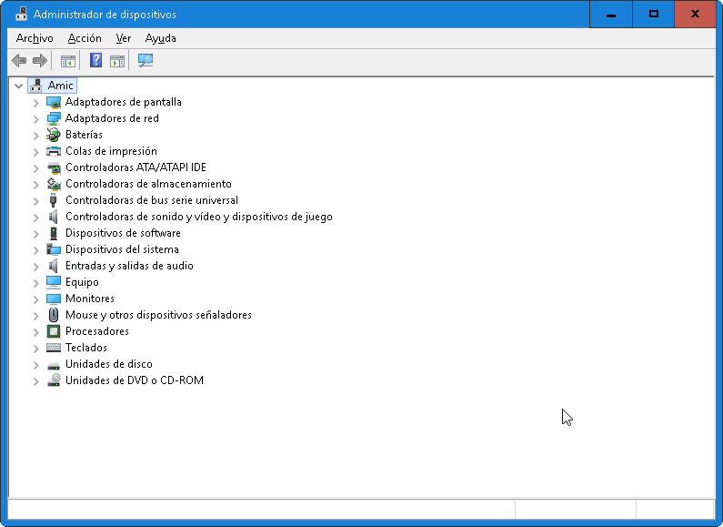
Basic management is explained in https://www.youtube.com/watch?v=kXIDFUlWUDs
The main operations that we can do are:
- Enable/Disable a device: useful when a component is causing trouble.
- Update driver of a device.
- Check state of a device.
- Uninstall components: several times is useful to uninstall a device to run again Windows auto configuration. It can solve a lot of problems.
- Some devices let you to do an advanced configuration (Example, configure energy saves in a WIFI device). Those features depend on the installed driver.

Security management
Windows 10 has several tools related to security. We are going to explain the most important tools available:
- BitLocker: BitLocker is a utility to cipher hard disk information. In this video you have information of how to use BitLocker to cipher a hard disk https://www.youtube.com/watch?v=nLh0jSfv6jA
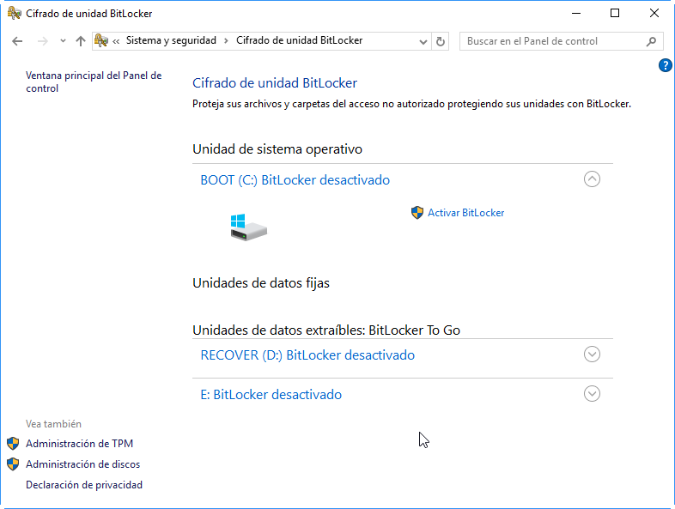
- Firewall: a firewall is a tool that monitors connections in our system and decides if a connection is accepted or denied. Firewall could be enabled or disabled.
  - In this video you can watch how to enable/disable firewall on Windows 10 https://www.youtube.com/watch?v=QhbzE6EBCno
  - In this video you can watch how to add a rule on the firewall https://www.youtube.com/watch?v=2AcqibSJ8ng
 If you have problems with a connection, the first step you have to do is disable your firewall to confirm if it is the problem.
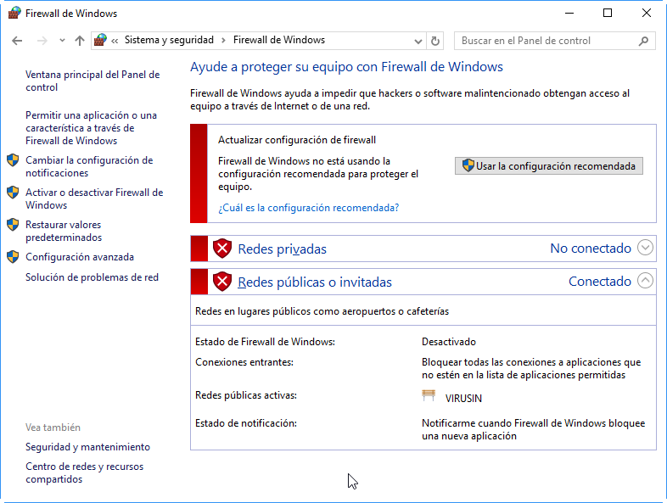

- Windows defender: Windows defender is an anti-virus created by Microsoft. Nowadays is a good alternative to other products like AVG, Avast, ….
  - To use it properly, you have to update virus databases and periodically run a scan.
  - In this video you can watch how to run a scan https://www.youtube.com/watch?v=dy7rHgPcbQc
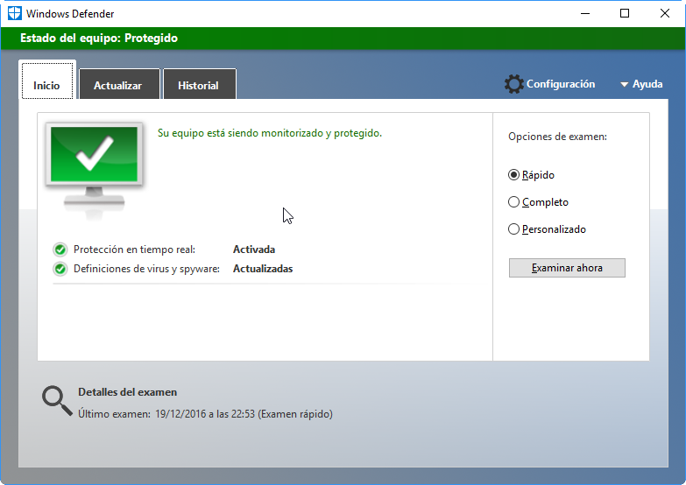

Disk Management
Disk management is menu to manage hard disk of our computer.
In this Video you can watch several ways to go to “Disk Management” in Windows 10 http://www.isunshare.com/windows-10/7-ways-to-open-disk-management-in-windows-10.html

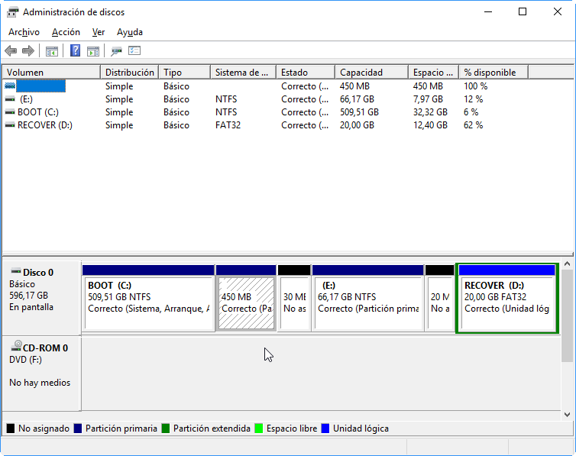
Disk management has several important operations like:
- Create/Delete a partition.
  - In this video you can watch how to create a partition https://www.youtube.com/watch?v=f8WzSRQ2NtY
- Shrink/Expand a partition.
  - In this video you can watch how to shrink and how to expand a partition https://www.youtube.com/watch?v=tJiakVgAtn4
- Create and manage Virtual Units (a file that works as a virtual unit).
  - In this video you can watch how to manage Virtual Units https://www.youtube.com/watch?v=gDLtOehX7NQ

Msconfig
Msconfig is a place where you can configure several things related with Windows 10 startup.
There are several ways to run Msconfig. The most common way is going to “Run” (Windows key + R) and type “msconfig”.
In this video you can watch other method to access to Msconfig https://www.youtube.com/watch?v=D0X29Jt2CKY
Msconfig has several tabs:
- General: you can select how to boot your system (complete, diagnosis) or select which components load.
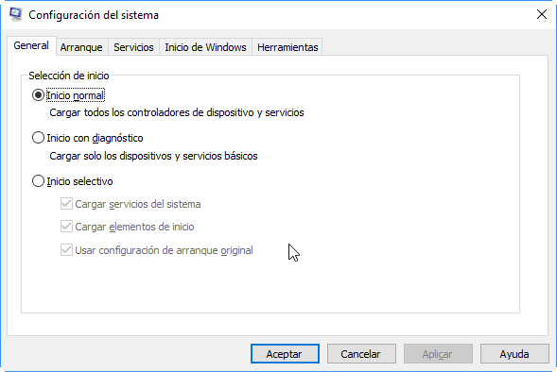
- Boot: you can configure Windows 10 boot manager.
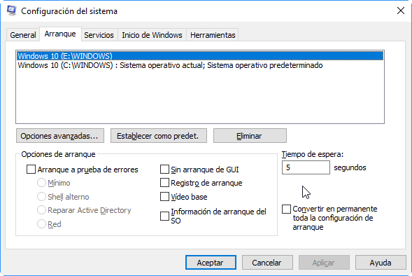
- Services: you can select services that will be started automatically when you start your computer.
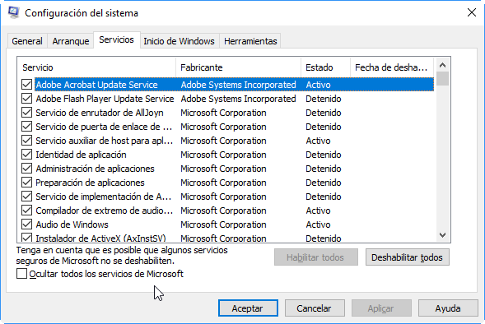
- Start: you can enable/disable applications that runs when Windows starts.
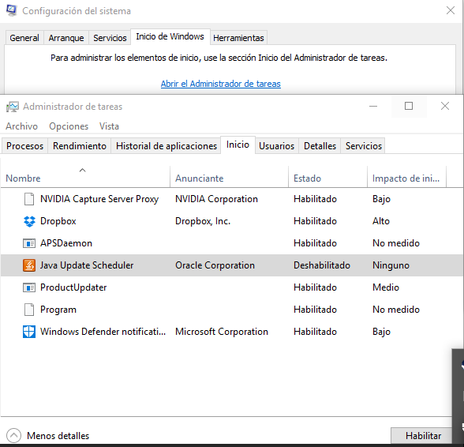
- Tools: you can use this tab as a shortcut to several system tools.
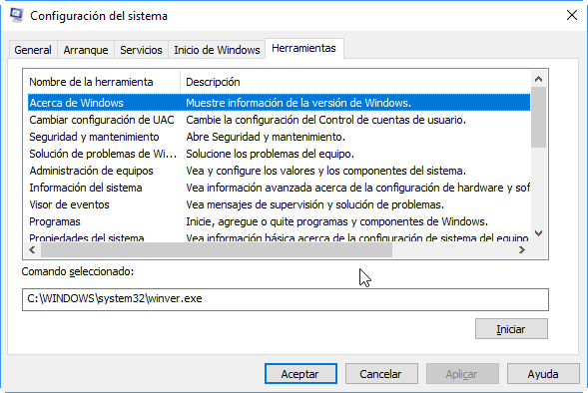

Additional material
[1] Windows Training
https://www.microsoft.com/en-us/learning/windows-training.aspx

Bibliography
[1] Windows 10
https://en.wikipedia.org/wiki/Windows_10
[2] Microsoft support
https://support.microsoft.com/

